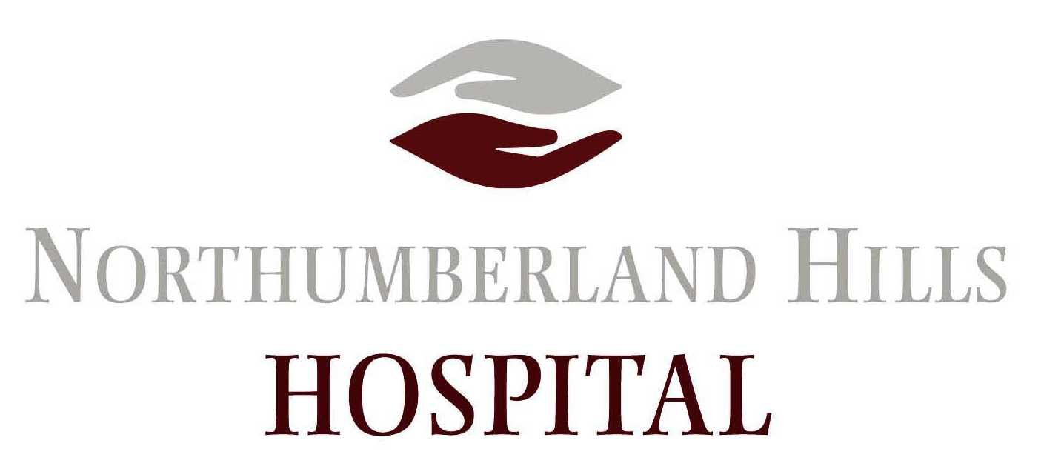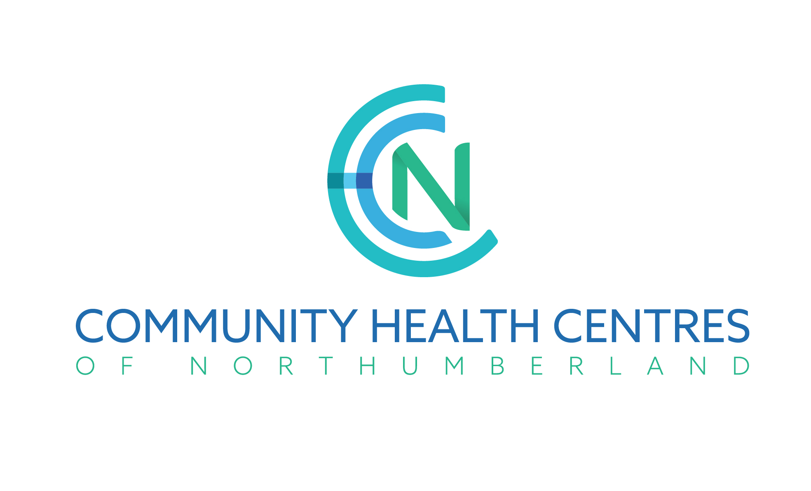

NEWS RELEASE – FOR IMMEDIATE RELEASE

2018/19 season of health and wellness talks launching September 19

Inspired by popular TED Talks, Northumberland PACE series aims to share info and spark dialogue on health topics top of mind with local audiences

NORTHUMBERLAND COUNTY, Monday, September 10, 2018—Championed by Northumberland Hills Hospital Chief of Staff Mukesh Bhargava, a group of area health-care providers and patients have come together to offer PACE 2018/19.

An acronym for Personalized Assessment and Change Education, PACE was launched three years ago by Dr. Bhargava, when he realized that a growing number of patients in his internal medicine practice were approaching him for more information on health-related changes they could make to get or stay healthy. The questions were typically around topics not covered in treatment, such as inquiries about the benefits of yoga or mindfulness.

“My patients knew what they needed to do,” said Dr. Bhargava, “like lose weight, eat better or get more exercise, but they often didn’t know where to go to get the specific information they needed on how to move in the right direction, and the supports or local services available to assist.”

Websites and handouts only worked for some, he realized. Face-to-face conversations were much more effective change agents, and so the PACE speakers’ series was born.

Free education sessions on hot topics, the Northumberland PACE talks have been promoted by Bhargava to a growing circle of past attendees. Topic ideas were simply “crowdsourced” by patients and others who approached him for information on health and wellness subjects.
Many attendees, including Carlos Osorio, have been attending the PACE talks from the start.
“I saw [the PACE talks] grow from 8-10 participants to over 50 as word spread how beneficial they were,” said Osorio. “The topics expanded from basic heart care, nutrition, exercises, medical drugs to other areas such as meditation, mindfulness, pain management, yoga, traditional herbal and other medicines, aging, stress management and others. Input was requested from the participants and the program was organized around what the group wished to hear. Group participation was encouraged by all speakers and the talks were not all one sided but interactive.”
In 2018, seeing the rising interest, Dr. Bhargava broadened his local planning for the series to include others also with an interest in education and knowledge building around health and wellness.

Northumberland Hills Hospital, the Northumberland Family Health Team (NFHT) and the Northumberland Community Health Centres (NCHC) have all joined Dr. Bhargava an informal planning table to build and expand PACE, together with a patient/caregiver representative from NHH’s Patient and Family Advisory Council (PFAC).

“We will continue to collect topic and speaker ideas from session attendees and the community at large. Our only requirement is that the speaker or speakers agree to speak for free, and that there is no solicitation,” said Dr. Bhargava.

In the past, one attendee has taken notes and these have been shared, verbatim, with all past attendees. Moving forward, the team is hoping to record the sessions, and ideally make them available online via live feed or podcast.
The 2018/19 PACE season is set to kick-off next week, on Wednesday, September 19th, with a discussion led by Dr. Bhargava himself, on the topic: “Integrative Wellness and the Use of Technology (Apps, Phones, Monitors) for Better Health”. Upcoming talk topics include preparing food for wellness and recovery (with registered dietitian Alan Hudson), pain management (with Dr. Francesco Mule) and mindfulness (with Dr. Jackie Gardner-Nix).
For a listing of all the 2018/19 speaker and topic line-up now confirmed, please see below or visit the PACE website at www.pacetalks.com.

Media contact: Jennifer Gillard, jgillard@nhh.ca or 905-377-7757.

About PACE – A collaborative between community health-care providers and local residents interested in learning more about health and wellness, PACE (which stands for Personalized Assessment and Change Education) is a TED Talks-inspired speakers’ series hosted (on a rotating basis) at Northumberland Hills Hospital in Cobourg and the Northumberland Community Health Centre in Port Hope. Talks are held monthly at 5:30 PM, September through June, on the third Wednesday of the month. One hour in total, each talk consists of a 30-minute presentation followed by a 20-minute, interactive question and answer speaker/audience discussion and a short moderator summary to conclude. Seats are available free of charge, on a first-come, first-reserved basis, and parking is FREE. Preregistration is required, to manage room occupancy limits. For information on upcoming sessions, to register for sessions of your choice, and to sign up for future alerts, please visit www.pacetalks.com.

– END –

