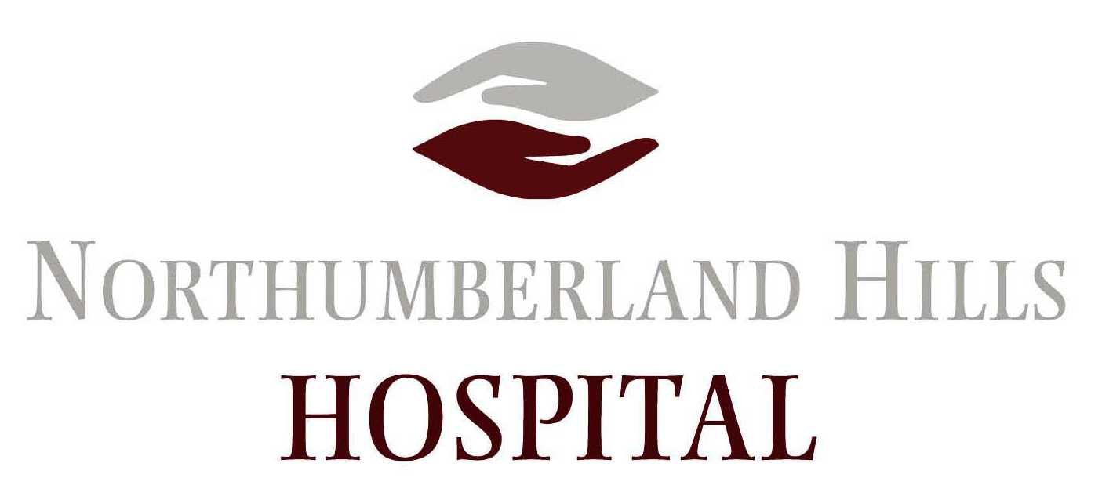

NEWS RELEASE – FOR IMMEDIATE RELEASE

Human Touch Award call for nominations –
Celebrate the heroes on the front lines of our cancer and kidney care system
NORTHUMBERLAND COUNTY, Wednesday, February 21, 2018—Do you know or work with someone who exemplifies the very best when it comes to providing compassionate person-centered care? Nominate them for a Human Touch Award.
Presented by Cancer Care Ontario (CCO), Ontario’s annual Human Touch Award celebrates the unsung heroes on the front lines of our cancer care and kidney care system who provide the true "human touch" to patients across our province every day. All part-time and full-time health care professionals, providers and volunteers who provide care in a regional cancer or kidney care program are eligible.
Nomination packages for kidney and cancer heroes are available now on CCO’s website at: https://www.ccohealth.ca/en/get-involved/awards/hta-nomination. The deadline for nominations is Wednesday, March 7.
Award recipients will be honoured at a provincial Human Touch Awards ceremony on June 14. The Central East Regional Cancer Program will also be recognizing all local nominees. Contact communications@cancercare.on.ca with any questions award the award.
About Northumberland Hills Hospital – Located approximately 100 kilometres east of Toronto, NHH delivers a broad range of acute, post-acute, outpatient and diagnostic services. Acute services include emergency and intensive care, medical/surgical care, obstetrical care and palliative care. Post-acute specialty services (PASS) include restorative care and rehabilitation. Mental health care, chemotherapy, dialysis and 16 other ambulatory care clinics are offered on an outpatient basis through partnerships with regional centres and nearby specialists. NHH offers a full range of diagnostic services, including magnetic resonance imaging (MRI), computed tomography (CT) and mammography. The hospital serves the catchment area of west Northumberland County. A mixed urban and rural population of more than 60,000 residents, west Northumberland comprises the Town of Cobourg, the Municipality of Port Hope and the townships of Hamilton, Cramahe and Alnwick/Haldimand. NHH employs approximately 600 people and relies on the additional support provided by physicians and volunteers. NHH is an active member of the Central East Local Health Integration Network. For more information, please visit www.nhh.ca or follow us on Twitter @NorHillsHosp.

